RAID-0 CONFIGURATION

,,,,,,,,,,,,,,,,,,,,,,,,,,,,,,,,,,,,,,,,,,,,,,,,,,,

Take 1 VM Machine add 20GB,20GB

systemctl stop firewalld

systemctl disable firewalld

vi /etc/selinux/config

init 6

lsblk

yum clean all

yum install mdadm

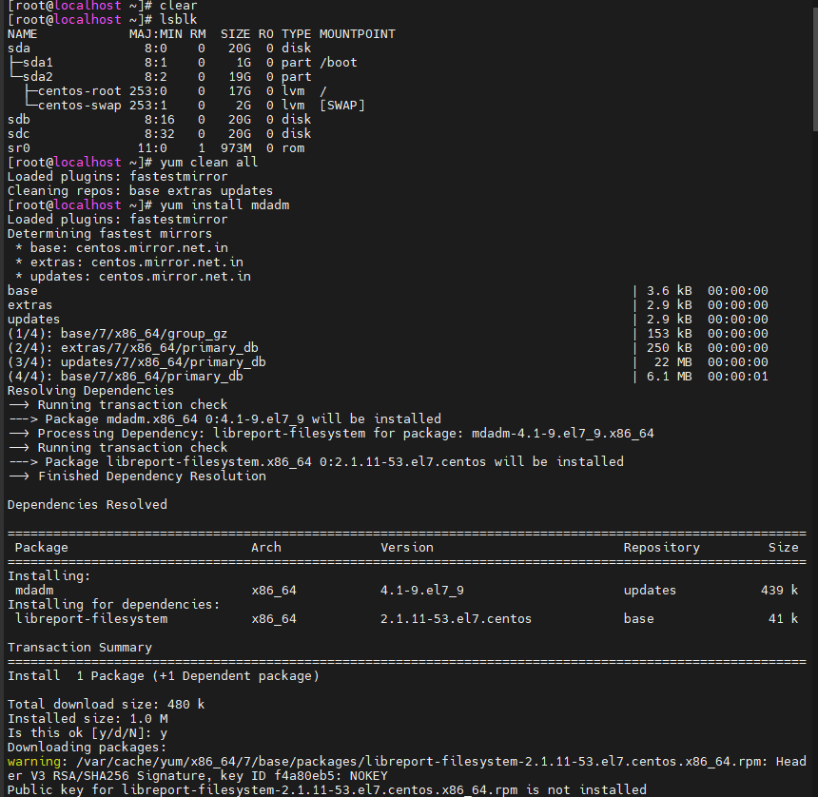

mdadm -h

mdadm --create --verbose /dev/md0 --level=0 --raid-devices=2

mdadm --create --verbose /dev/md0 --level=0 --raid-devices=2 /dev/sdb /dev/sdc

cat /proc/mdstat

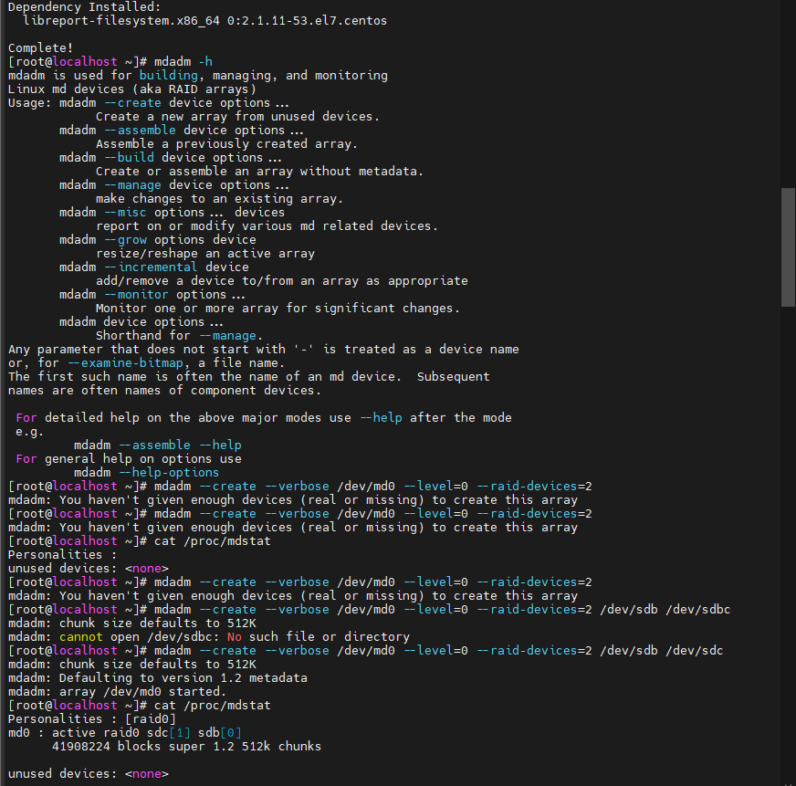

lsblk

fdisk /dev/md0

lsblk

mkfs.ext4 /dev/md0p1

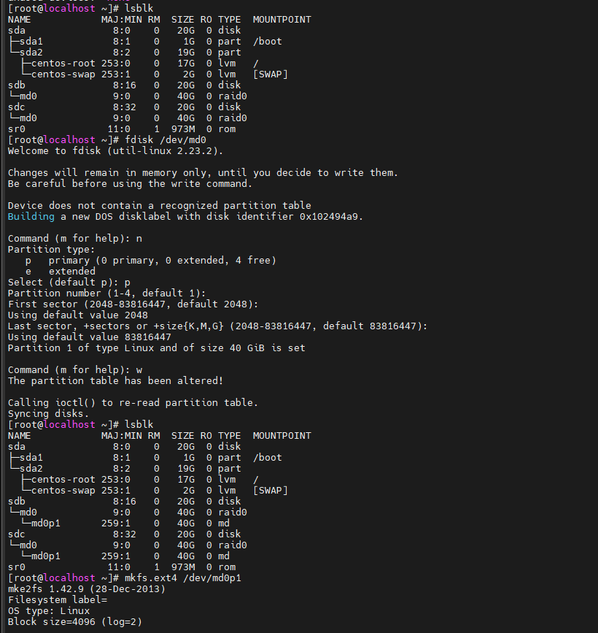

mkdir /mnt/raid0

mount /dev/md0p1 /mnt/raid0/

mdadm --detail /dev/md0

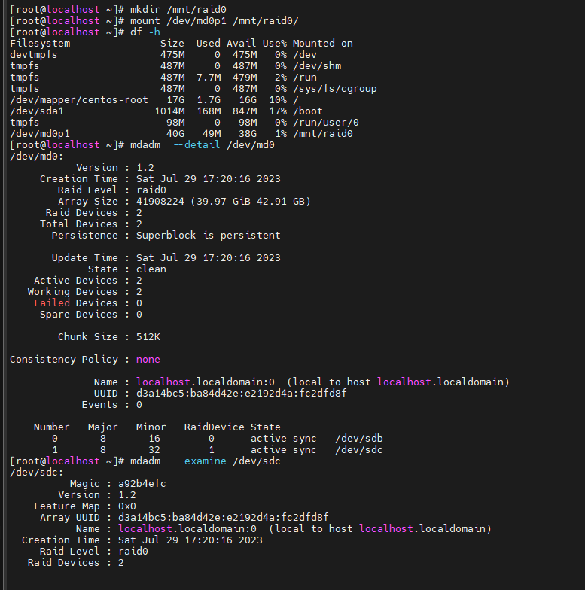

mdadm --examine /dev/sdc

fdisk –l

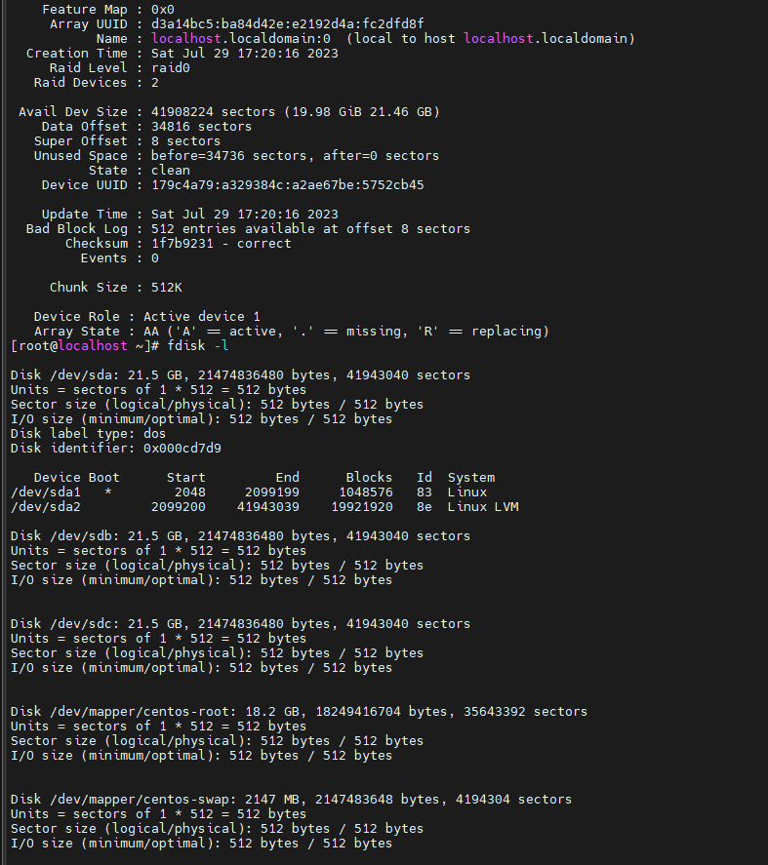

cd /mnt/raid0/

ls

touch test

ls

dd if=/dev/zero of=500mb.file bs=1024 count=502400

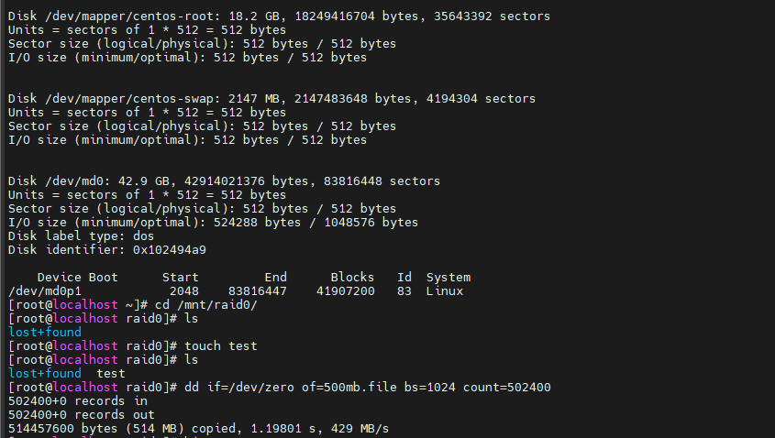

1 systemctl stop firewalld

2 systemctl disable firewalld

3 vi /etc/selinux/config

4 init 6

5 clear

6 lsblk

7 yum clean all

8 yum install mdadm

9 mdadm -h

10 mdadm --create --verbose /dev/md0 --level=0 --raid-devices=2

11 cat /proc/mdstat

12 mdadm --create --verbose /dev/md0 --level=0 --raid-devices=2

13 mdadm --create --verbose /dev/md0 --level=0 --raid-devices=2 /dev/sdb /dev/sdbc

14 mdadm --create --verbose /dev/md0 --level=0 --raid-devices=2 /dev/sdb /dev/sdc

15 cat /proc/mdstat

16 lsblk

17 fdisk /dev/md0

18 lsblk

19 mkfs.ext4 /dev/md0p1

20 mkdir /mnt/raid0

21 mount /dev/md0p1 /mnt/raid0/

22 df -h

23 mdadm --detail /dev/md0

24 mdadm --examine /dev/sdc

25 fdisk -l

26 cd /mnt/raid0/

27 ls

28 touch test

29 ls

30 dd if=/dev/zero of=500mb.file bs=1024 count=502400